<$Scr_Cs::0>cffi<!$Scr_Cs::0> on Windows requires seperate installation of a C++ compiler (they reccomend Microsoft’s) and libraries from the Windows SDK. When installing dependencies from pip, cffi will throw an error and terminate installation if it does not find them. Refer to https://wiki.python.org/moin/WindowsCompilers and the cffi docs for an overview of the subject.
To install Microsoft’s C++ compiler and libraries if you don’t already have them:
- Visit https://visualstudio.microsoft.com/downloads/
- Browse to “Tools for Visual Studio” (2019 as of this writing). From the drop-down, find “Build Tools for Visual Studio” and download the installer from the link (<$Scr_Cs::0>vs_BuildTools.exe<!$Scr_Cs::0>).
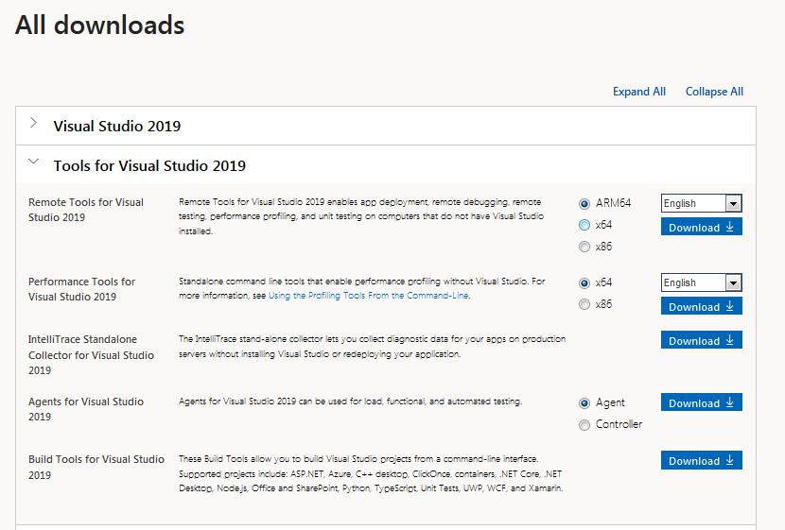
- Run the installer, click “Continue” and wait for the installer to run its preliminary setup.
- The installer will allow you to select only the components you need. Select “Individual Components” from the tabs along the top.
- In the search box, type “MSVC” (which stands for MicroSoft Visual C). Select the checkbox for the most recent version of the build tools for your platform. (For example: “<$Scr_Cs::0>MSVC v142 - VS 2019 C++ x64/x86 build tools (v14.23)<!$Scr_Cs::0>” will install version 14.23 of the tools for x64/x86 platforms.) The minimum supported version is 14.0.
- In the search box, type “Windows”, scroll down to “SDKs, Libraries and Frameworks” and select the checkbox for the most recent version of the Windows SDK. (With Visual Studio 2019, this will be the Windows 10 SDK, even if your system isn’t Windows 10).
- Click “Install” in the bottom-right and wait for the components to download and install.
If you need to add, change or remove components, you can run the Visual Studio installer again and select “Modify” from the “Visual Studio Build Tools” options.
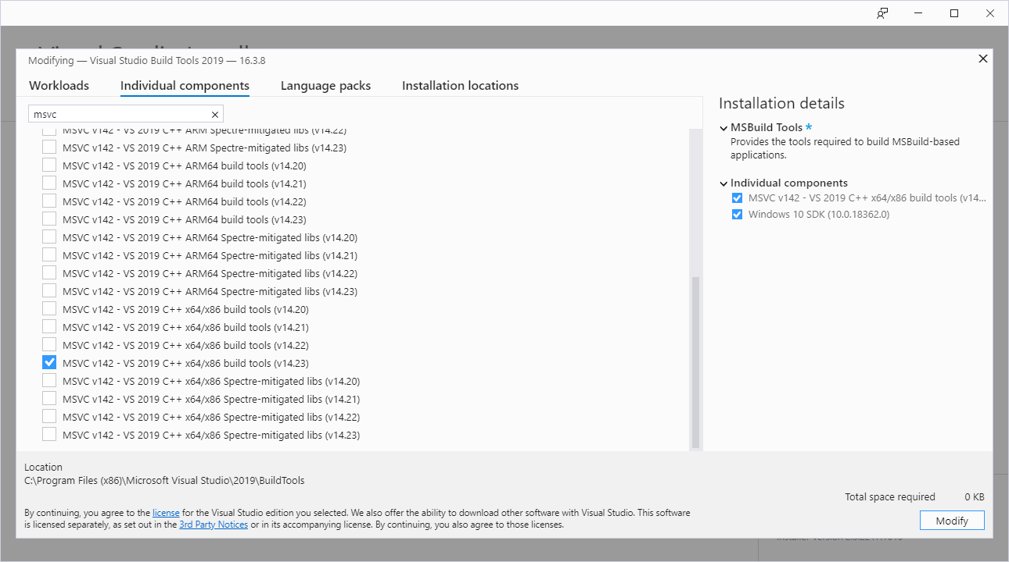

Building the Virtual Environment
Once you have installed all external dependencies, you should be able to build a new virtual environment within the Git repository.
- Open a command prompt and <$Scr_Cs::0>cd<!$Scr_Cs::0> to the <$Scr_Cs::0>island-manager<!$Scr_Cs::0> directory.
- Run: <$Scr_Cs::0>python -m venv env<!$Scr_Cs::0> to create the virtual environment directory.
- Run <$Scr_Cs::0>.\env\Scripts\activate.bat<!$Scr_Cs::0> to enable the virtual environment.
- Install dependencies by running <$Scr_Cs::0>pip install -r requirements.txt<!$Scr_Cs::0> .
- Run <$Scr_Cs::0>main.py<!$Scr_Cs::0> to run and test Islands Manager.
- If you wish to use IDLE (the default Python IDE) with the virtual environment, invoke it from the command line with <$Scr_Cs::0>python -m idlelib.idle <!$Scr_Cs::0>while within the virtual environment. For other editors, consult their documentation.

A Note on Cryptography and OpenSSL
Islands Manager itself does not use SSL for any of its functions. However, the cryptography module includes support for OpenSSL alongside many other cryptographic methods. The pre-compiled packages from pip include static-linked OpenSSL libraries. However, if there is no pre-compiled binary of cryptography for the active version of Python, pip will attempt to compile it. Compiling cryptography requires OpenSSL to be available on the system. This is likely to fail on Windows, which does not come with OpenSSL installed by default, unlike most UNIX and macOS systems.
The preferred solution is to stick with a cryptography version that has pre-built support for the active Python version. The version specified in <$Scr_Cs::0>requirements.txt<!$Scr_Cs::0> should meet this requirement. If you hit this error, check that you are building your virtual environment with a supported Python version.
If for some reason you absolutely must build your own cryptography package, the process is covered in the cryptography docs. Source downloads for OpenSSL are available here. There are no official Windows binaries for OpenSSL but an approved list of third-party binaries is maintained here.

